Facebook的 C++ HTTP 库：Proxygen

[Proxygen](http://www.open-open.com/lib/tag/Proxygen)   2014-11-06 10:25:04 发布

|  |  |  |  |
| --- | --- | --- | --- |
| **您的评价**: |  | **0.0** | 很差 |

[收藏](javascript:void(0))     0收藏

该项目包括 Facebook使用的核心 C++抽象HTTP。在内部，它被用作构建HTTP服务器，代理服务器和客户端的基础库。本次发布的重点是常见的HTTP抽象和简单的HttpServer框架。未来版本将提供简单的客户端API。该框架支持HTTP/1.1，SPDY/3，和SPDY/3.1。 HTTP /2支持正在进行中。我们的目标是提供一个简单，高性能，以及现代的C++ HTTP库。  


目录结构和内容：

* proxygen/external/ Contains non-installed 3rd-party code proxygen depends on.
* proxygen/lib/ Core networking abstractions.
* proxygen/lib/http/ HTTP specific code.
* proxygen/lib/services/ Connection management and server code.
* proxygen/lib/ssl/ TLS abstractions and OpenSSL wrappers.
* proxygen/lib/utils/ Miscellaneous helper code.
* proxygen/httpserver/ Contains code wrapping proxygen/lib/ for building simple C++ http servers. We recommend building on top of these APIs.

架构

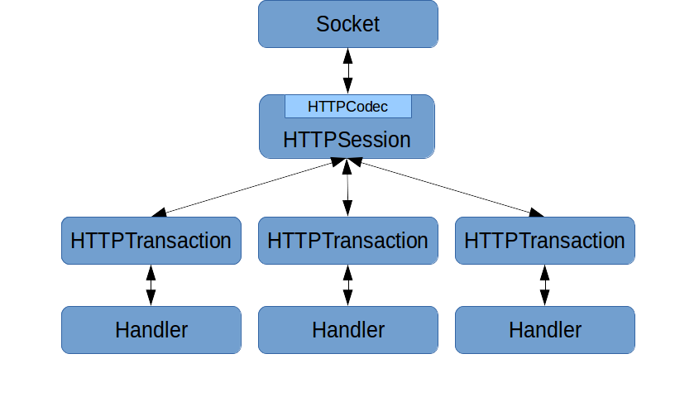

基础组件是HTTPServer, RequestHandlerFactory, 和 RequestHandler。An HTTPServertakes some configuration and is given aRequestHandlerFactory. Once the server is started, the installedRequestHandlerFactory spawns a RequestHandler for each HTTP request. RequestHandler is a simple interface users of the library implement. Subclasses of RequestHandler should use the inherited protected member ResponseHandler* downstream_ to send the response.

**项目主页：**<http://www.open-open.com/lib/view/home/1415238647480>